56.

58. 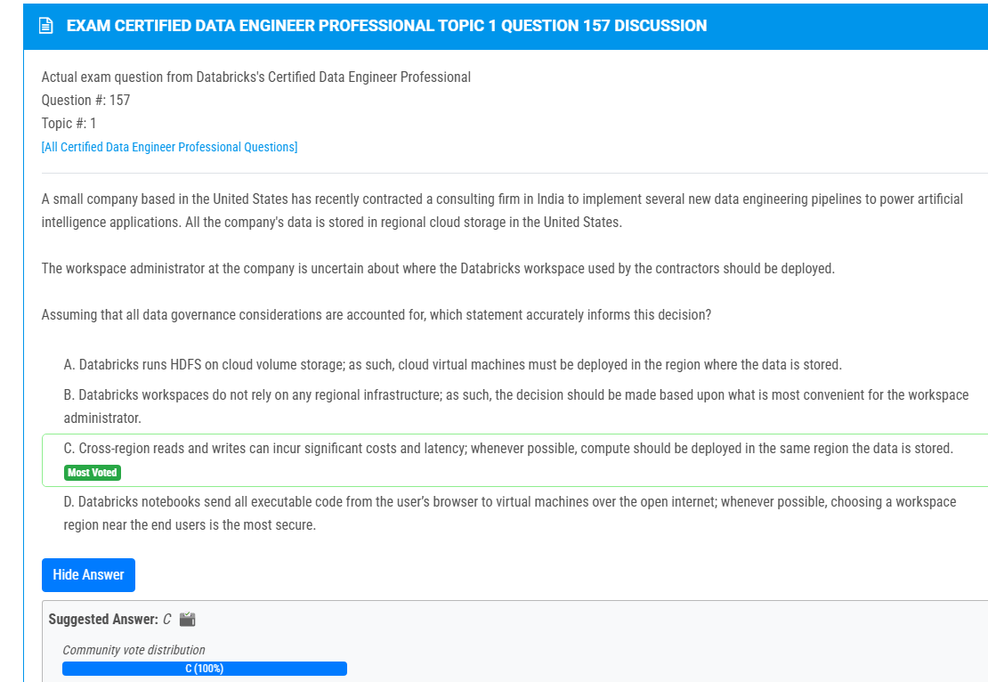

59. 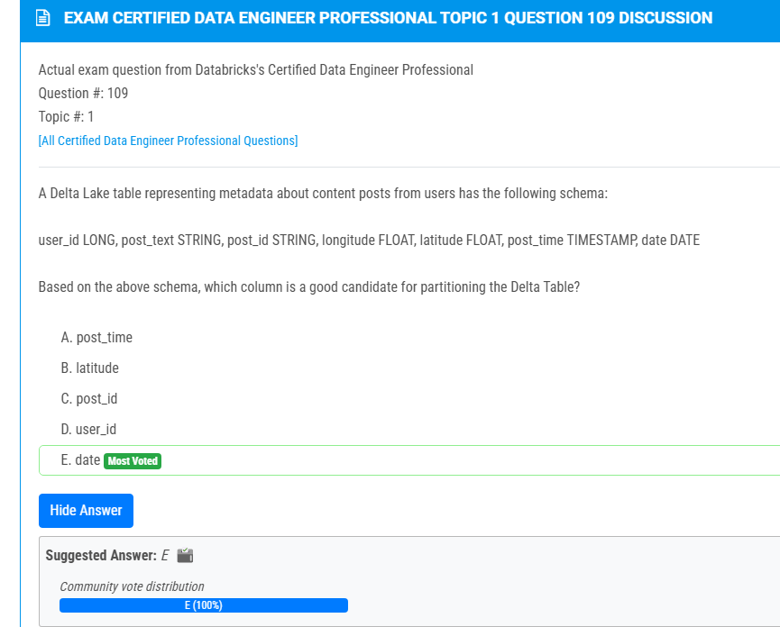  
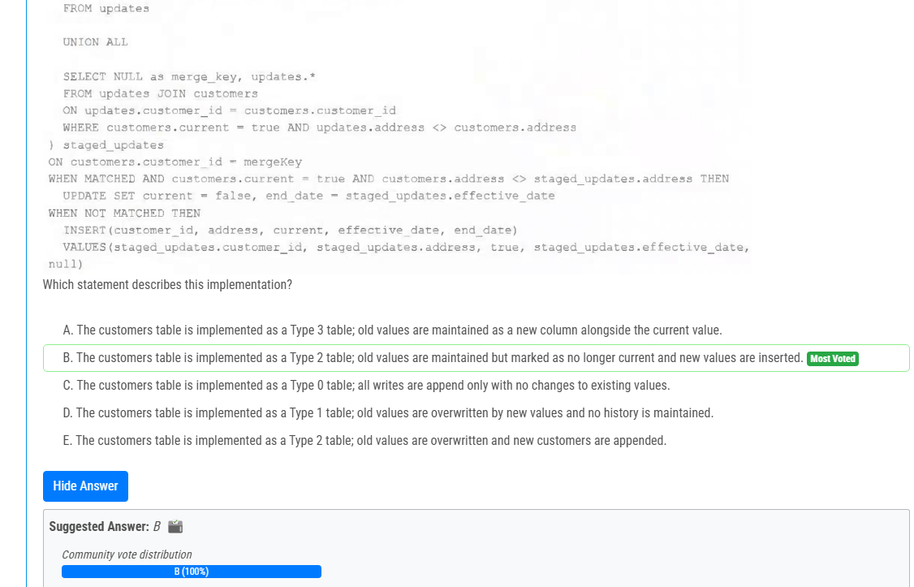

63. 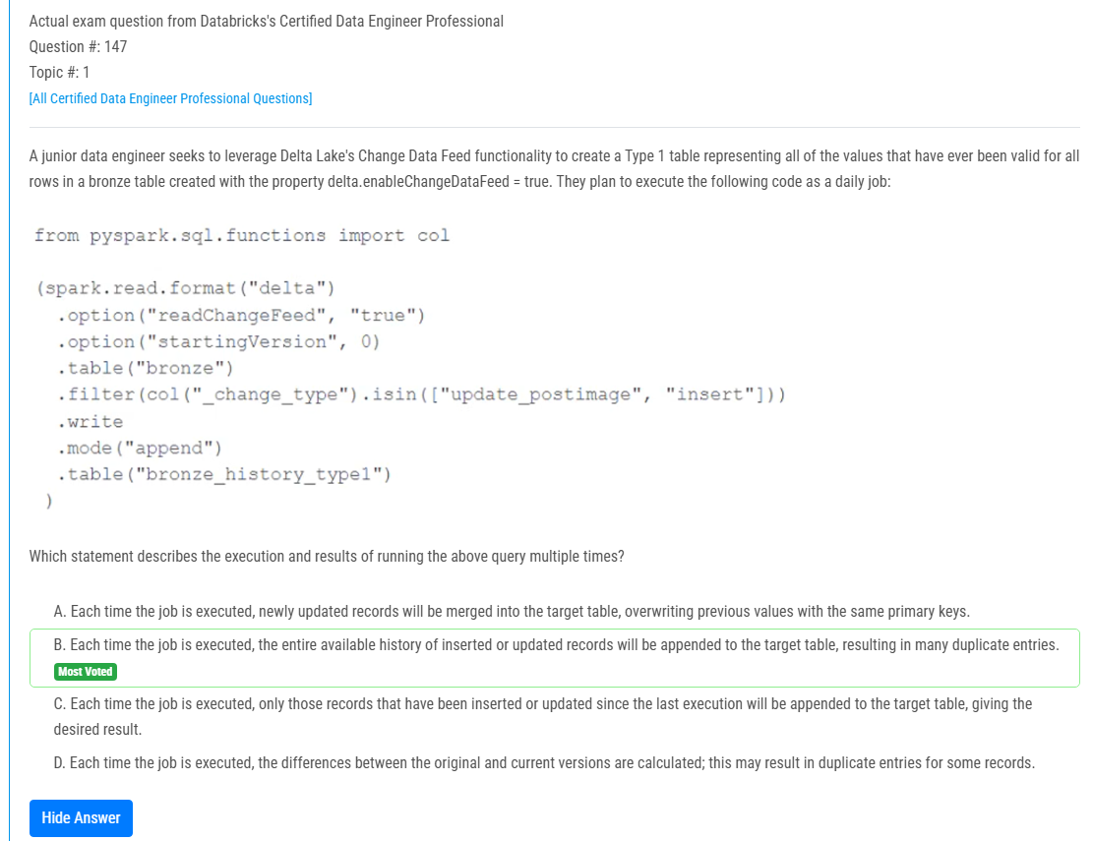

65.  
67.  
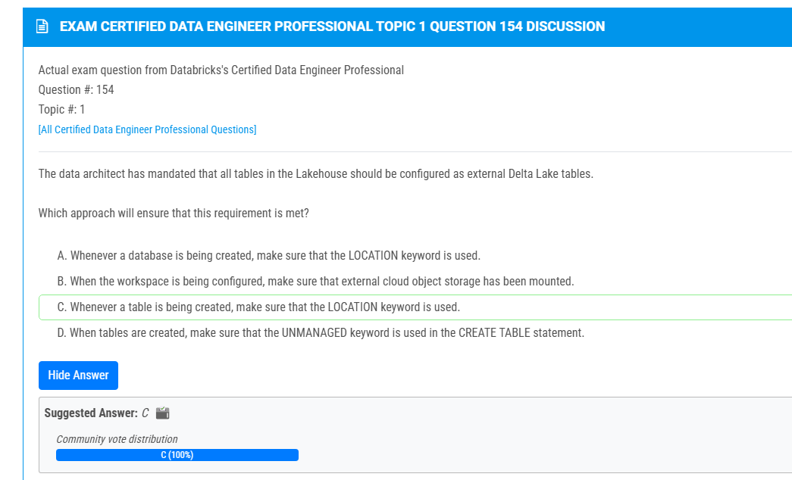

71. 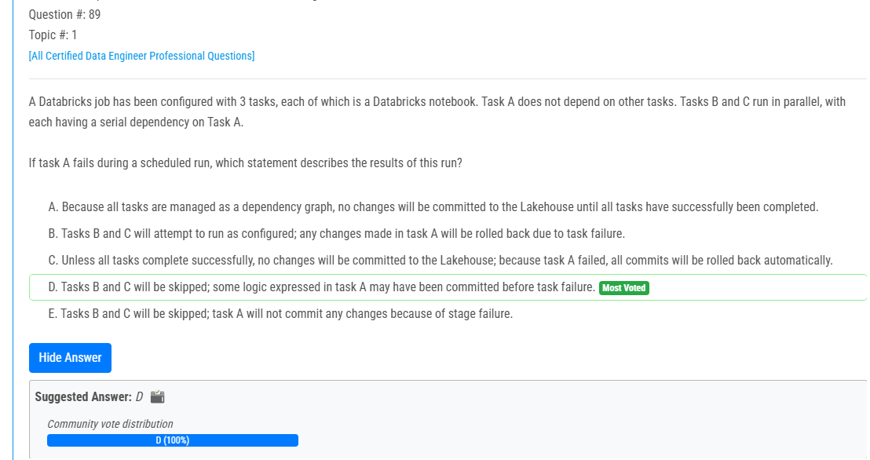 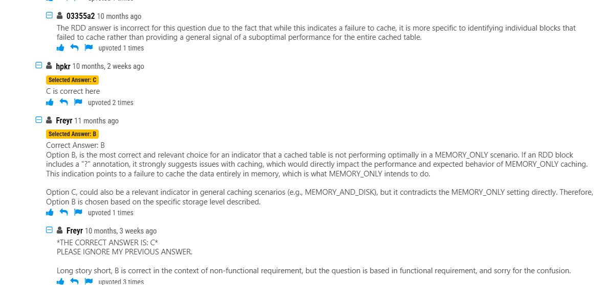

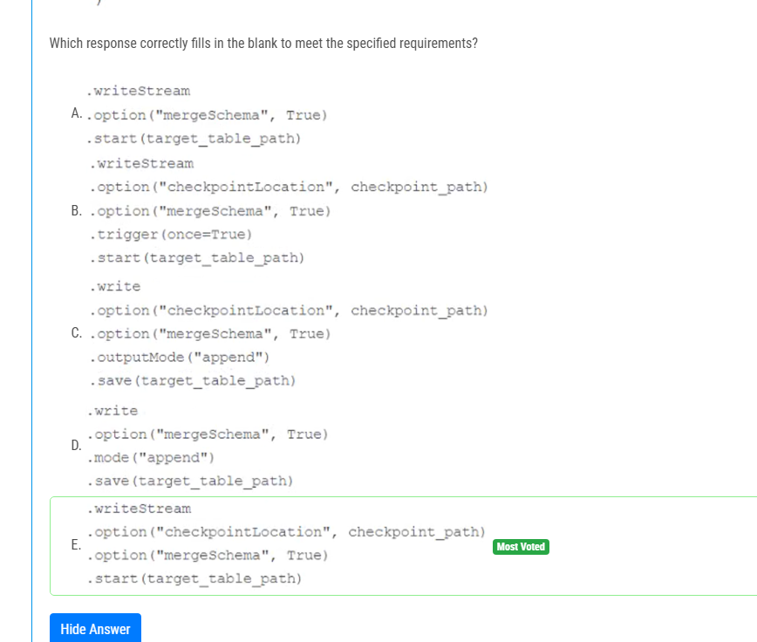

81.

84. 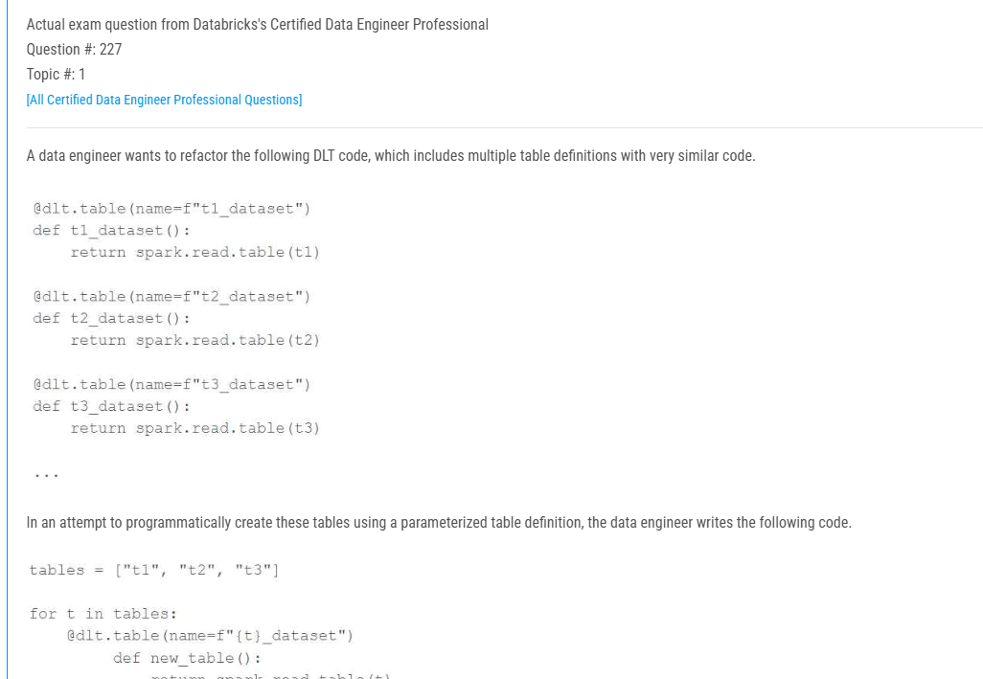

85. 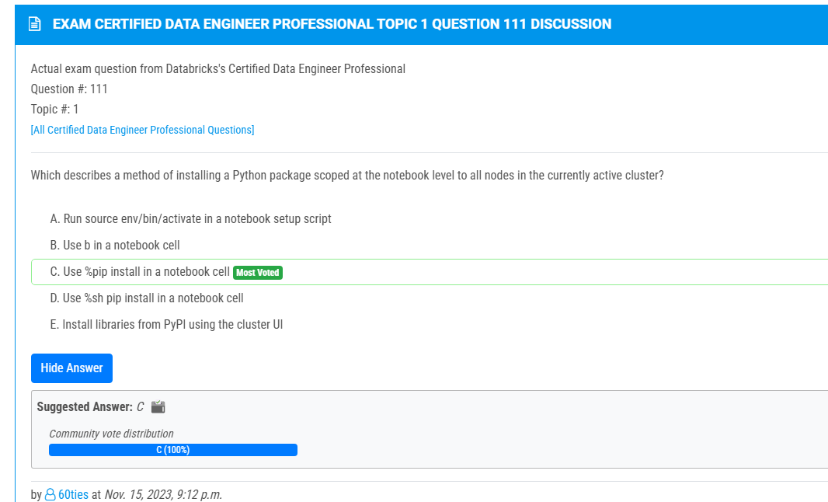

89. 